CpE 3110/CS 3803 Homework Assignment #4 Max – 100pts

You must always show or explain your work in a neat and orderly format. You are encouraged to discuss ideas with other students and consult references but your work must be your own.

Be sure to show your work/derivation for full credit (or maximum possible partial credit, if your final answer is not right). Also, do your best to maximize your HW score, since 13% of your semester letter grade will be decided by your HW performance.

For the single-cycle LEGv8 processor design given below, answer the following questions:

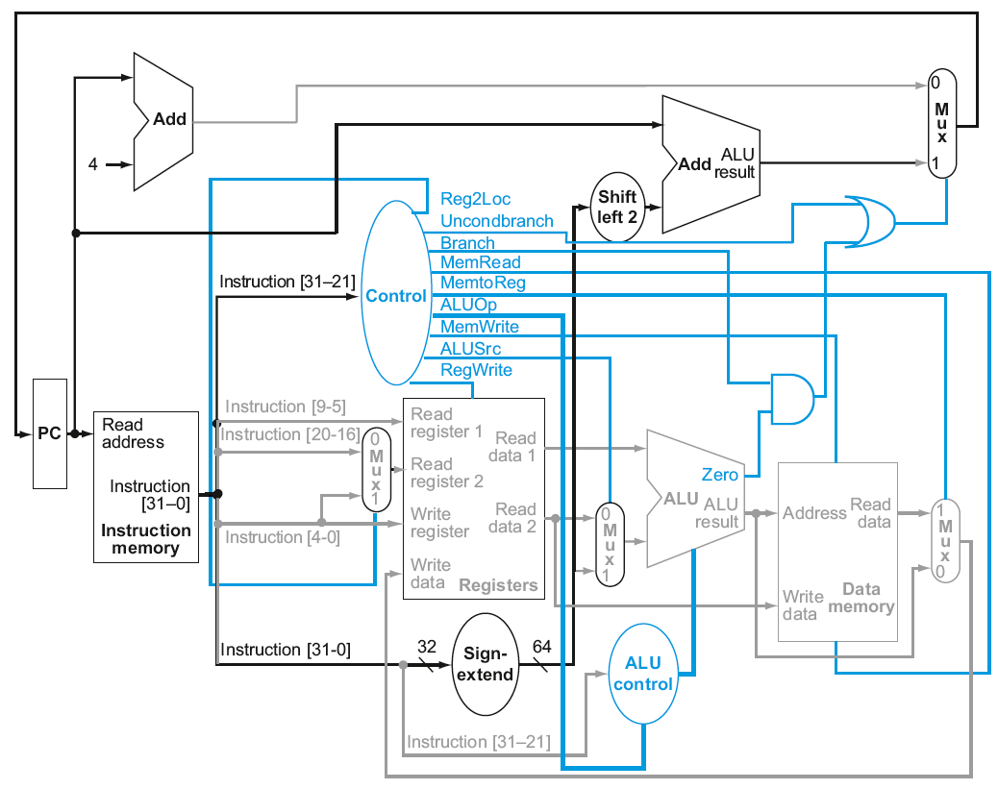
Figure 1Single-cycle LEGv8 processor architecture

- List all combinational logic components used in this design. [10pts]

- List all sequential logic components used in this design. [10pts]

- Among the following instructions implemented in this design, which ones may use the 64b output from the sign-extend unit? Clearly justify your answer. [10pts]

Memory reference: LDUR, STUR
Arithmetic/logical: ADD, SUB, AND and ORR
Control transfer: CBZ and B

- Find appropriate values for all control signals (Reg2Loc, Uncondbranch, Branch, MemRead, MemtoReg, 2-bit ALUOp, MemWrite, ALUSrc, RegWrite and 4-bit ALU control) to execute each of the following instructions. Note MemRead/MemWrite should be 00, 10 and 01 for hold/read/write operations, respectively. Also, make sure to use don’t cares when possible: [50pts]

Loop: ADD X10, XZR, SP
ADD X9, X10, X11
LDUR X9, [X10, #-16]
CBZ X9, Loop
STUR X9, [X10, #-8]
B Loop

- For the instruction sequence given in the previous question, calculate the 64b output from the shift left 2 unit for CBZ instruction and B instruction. Clearly show your work. [20pts]

